Сontent
Part 1 Matlab Simulink processing 2
Part 2 Python processing 6
Part 3 Python code 10

Part 1 Matlab Simulink processing
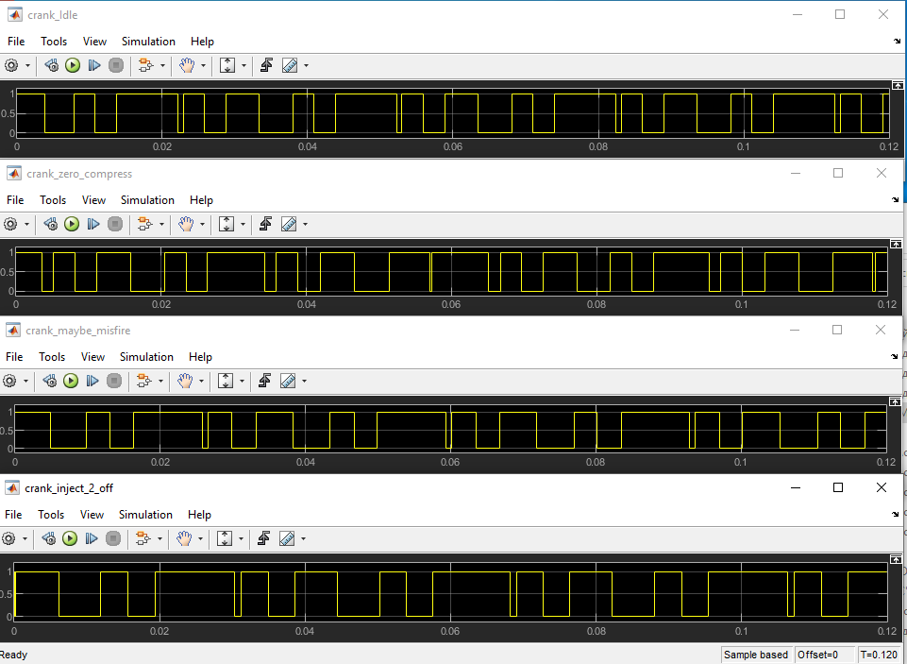
Raw_signal_of_crank (matlab simulink), duration 0.12 s

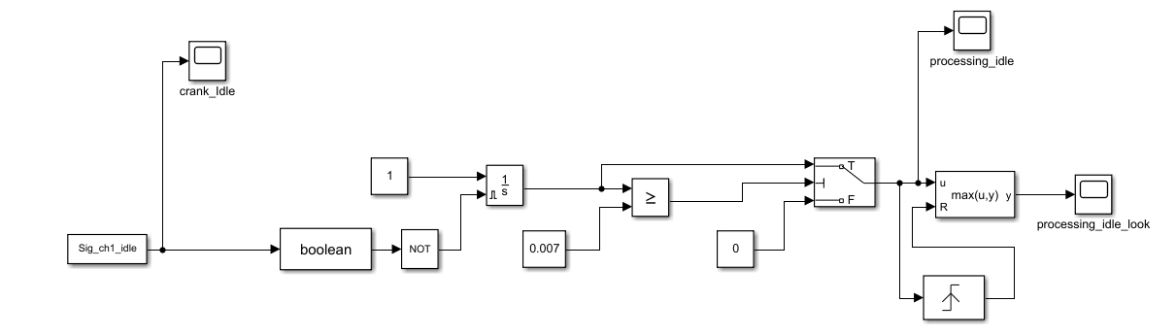
Simulink model
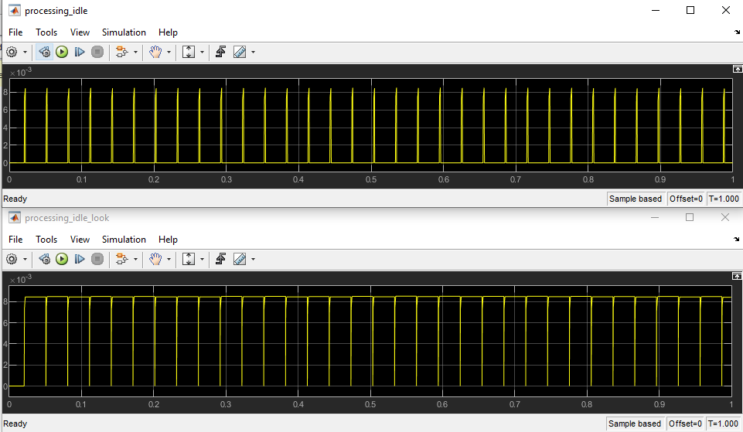
Result idle signal processing, duration 1 s

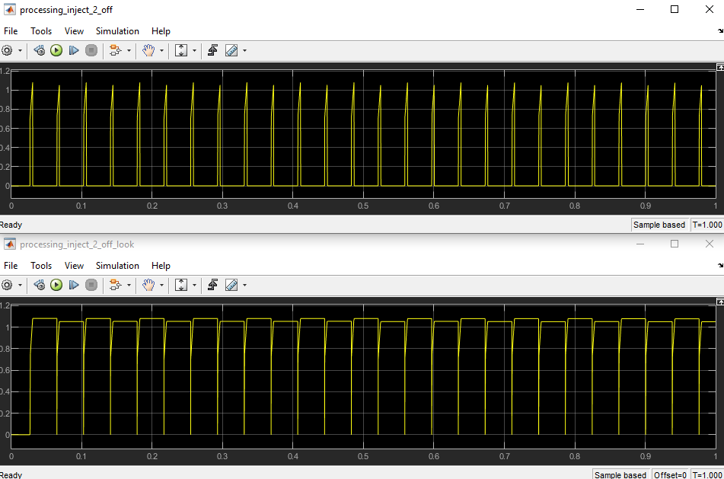
Result inject_2 off signal processing, duration 1 s

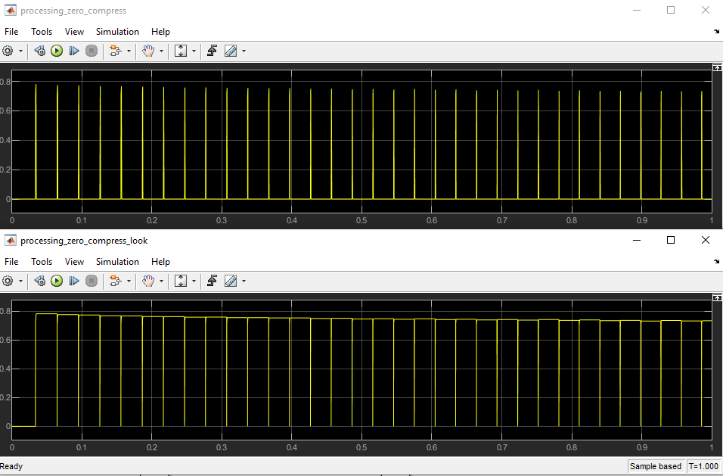
Result zero compressing signal processing, duration 1 s
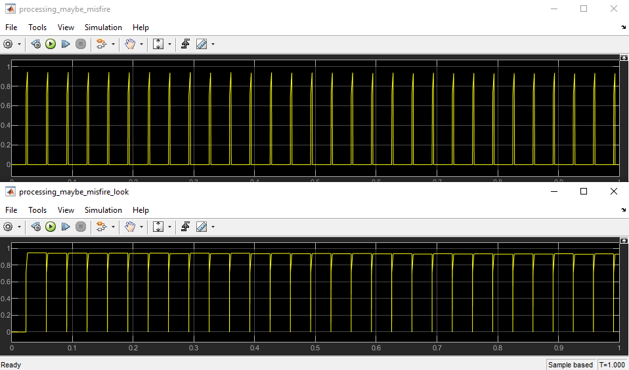
Result maybe misfire signal processing, duration 1 s

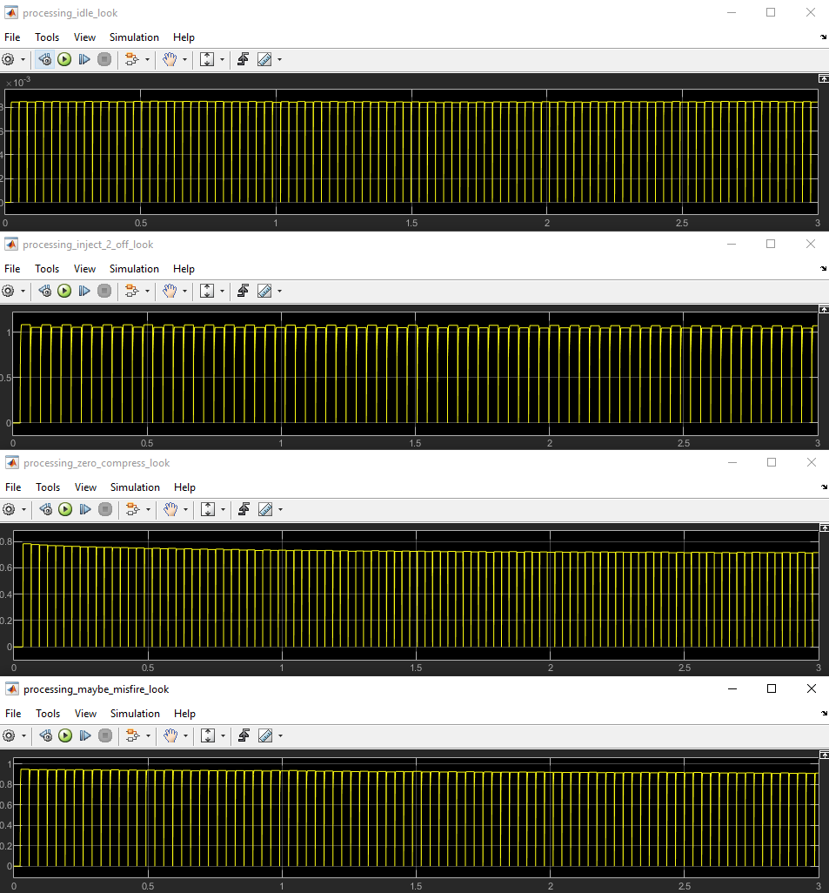
Signals processing, duration 3 s

Part 2 Python processing
Period calc by crank signal and time series data:
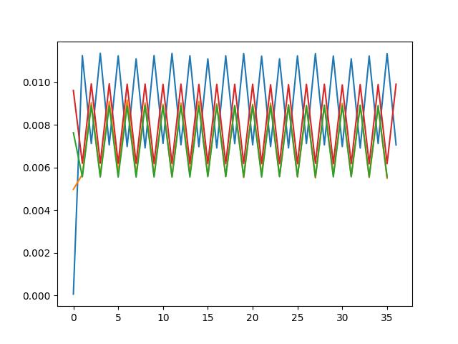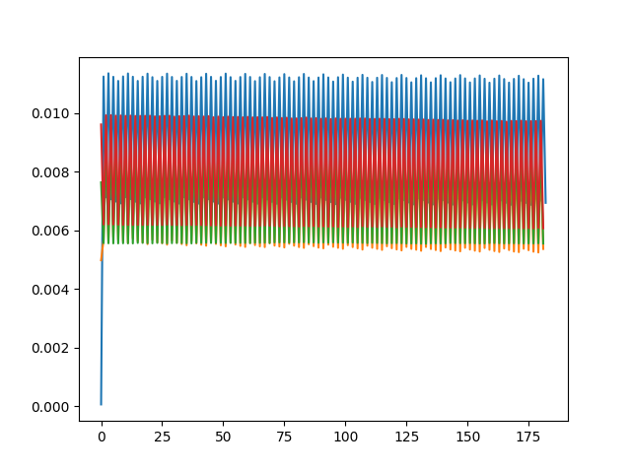
green – idle, blue – inject 2 off, yolo (bed look on picture..) – zero compression, red – suspected bad sparkplug
About Y axis – calc period, About X axis – number of data

Filtered by level (0.007 s) period data:
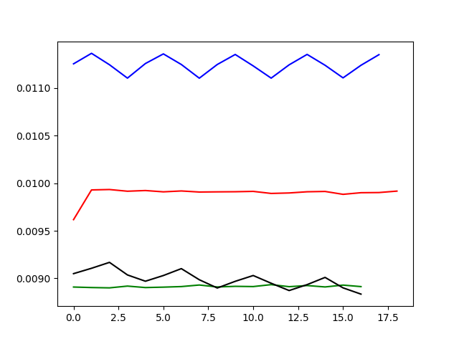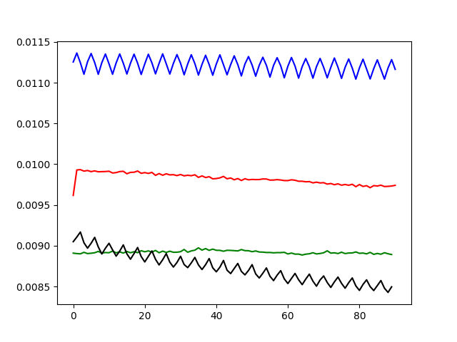
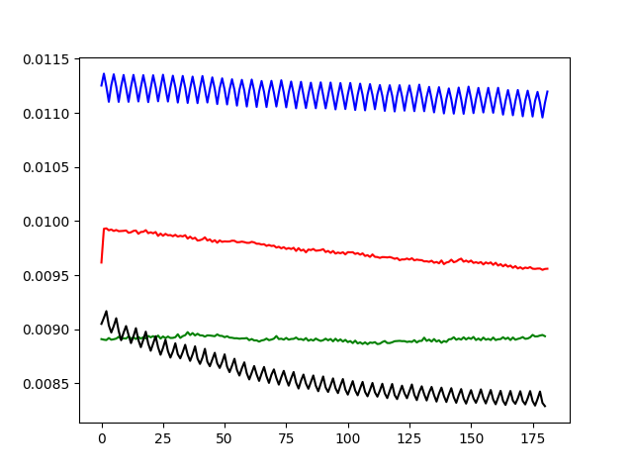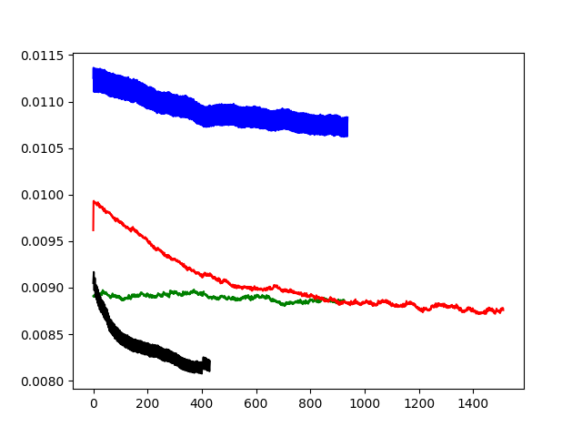
green – idle, blue – inject 2 off, black – zero compression, red – suspected bad sparkplug
About Y axis – calc period, About X axis – number of data

Filtered and diff period data:
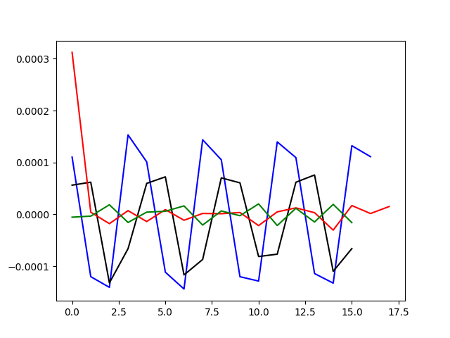
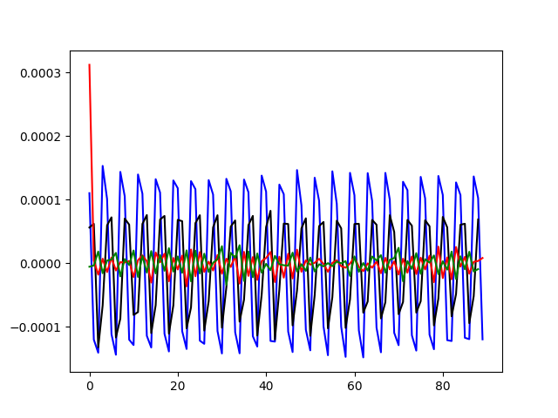
green – idle, blue – inject 2 off, black – zero compression,
red – suspected bad sparkplug
(see next page)
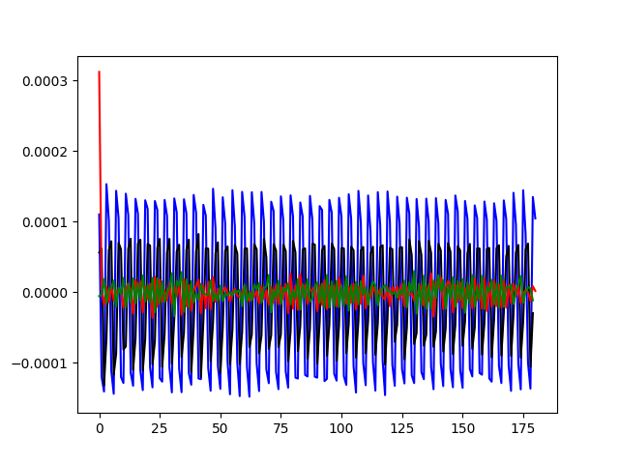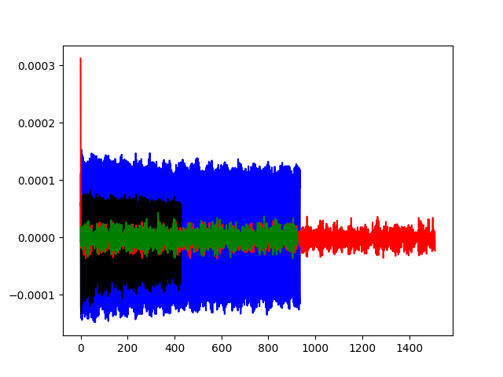
green – idle, blue – inject 2 off, black – zero compression,
red – suspected bad sparkplug
About Y axis – calc period, About X axis – number of data

Part 3 Python code

import csv
import numpy as np
from matplotlib import pyplot as plt

path_file_idle = r'C:\Users\home\Documents\nb2-happy-warmup-idle.csv'
path_file_miss = r'C:\Users\home\Documents\nb2-idle-without-injector-2.csv'
path_file_zero = r'C:\Users\home\Documents\nb2-sparkplug-1-completely-removed-zero-compression-in-1.csv'
path_file_maby = r'C:\Users\home\Documents\nb2-suspected-bad-sparkplug-1.csv'

def parse_data(path_file_idle):
data = np.array([[]])
time_s = []
cam = []
crank = []
with open(path_file_idle) as csvfile:
reader = csv.DictReader(csvfile)
for row in reader:
cam.append(row['cam'])
time_s.append(row['Time [s]'])
crank.append(row['crank'])

cam = np.array(cam)
time_s = np.array(time_s)
crank = np.array(crank)

cam = cam.astype(int)
time_s = time_s.astype(float)
crank = crank.astype(int)

#plt.plot(crank[:100])

data = np.vstack((crank, time_s)).T
print(data.shape)
return data

data_idle = parse_data(path_file_idle)
data_miss = parse_data(path_file_miss)
data_zero = parse_data(path_file_zero)
data_maby = parse_data(path_file_maby)

def invert_value(in_val):
out_val = []
for i in range(in_val.shape[0]):
if in_val[i] == 0:
out_val.append(1)
else:
out_val.append(0)
return out_val

def calc_period(data):
sig_period = []
t_0 = data[0, 1]
t_1 = float()
print('perid in data len --> ', data.shape[0])
for i in range(data.shape[0]):# 100
if i == 0:
crank_current = data[0, 0]
print('ferst_data')
pass
crank_mem = crank_current
crank_current = data[i, 0]

if crank_current == crank_mem:
pass

if crank_current > crank_mem:
t_0 = data[i, 1]

if crank_current < crank_mem:
t_1 = data[i, 1]
period = t_1 - t_0
sig_period.append(period)
'''
if i == 2000:
break
'''

sig_period = np.array(sig_period)

sig_period = sig_period.astype(float)
print(sig_period.shape)
return sig_period

sig_period_idle = calc_period(data_idle)

sig_period_miss = calc_period(data_miss)

sig_period_zero = calc_period(data_zero)

sig_period_maby = calc_period(data_maby)

#print(sig_1)

plt.figure('period')
plt.plot(sig_period_miss)
plt.plot(sig_period_zero)
plt.plot(sig_period_idle)
plt.plot(sig_period_maby)

level = 0.008
def filt_level(level, data_in):
data_out = []
for i in range(data_in.shape[0]):
if data_in[i] >= level:
data_out.append(data_in[i])
else:
pass
return data_out

filt_level_data_idle = filt_level(level, sig_period_idle)

filt_level_data_miss = filt_level(level, sig_period_miss)

filt_level_data_zero = filt_level(level, sig_period_zero)

filt_level_data_maby = filt_level(level, sig_period_maby)

plt.figure('filt')
plt.plot(filt_level_data_idle, color='green')
plt.plot(filt_level_data_miss, color='blue')
plt.plot(filt_level_data_zero, color='black')
plt.plot(filt_level_data_maby, color='red')

filt_and_diff_level_data_idle = np.diff(filt_level_data_idle)
filt_and_diff_level_data_miss = np.diff(filt_level_data_miss)
filt_and_diff_level_data_zero = np.diff(filt_level_data_zero)
filt_and_diff_level_data_maby = np.diff(filt_level_data_maby)

plt.figure('filt_and_diff')
plt.plot(filt_and_diff_level_data_miss, color='blue')
plt.plot(filt_and_diff_level_data_zero, color='black')
plt.plot(filt_and_diff_level_data_maby, color='red')
plt.plot(filt_and_diff_level_data_idle, color='green')

sensor_level = 0.00007
def sensor(sensor_level, data_in):
miss = []
miss_value = []
print('count_cycle -->', data_in.shape[0])
for i in range(data_in.shape[0]):
if i == 0:
val_current = data_in[0]
pass
val_mem = val_current
val_current = data_in[i]

if abs(val_current - val_mem) >= sensor_level:
miss.append(i)
miss_value.append(abs(val_current - val_mem))
print('count miss --> ', len(miss))
if len(miss) <= 30:
print('numba_of_cycle_miss -->', miss)
print('numba_of_cycle_miss_value -->', miss_value)
return miss

miss_idle = sensor(sensor_level, filt_and_diff_level_data_idle)
miss_miss = sensor(sensor_level, filt_and_diff_level_data_miss)
miss_miss = sensor(sensor_level, filt_and_diff_level_data_zero)
miss_maby = sensor(sensor_level, filt_and_diff_level_data_maby)

def SKO():
pass

plt.show()

#print(cam_idle)
#print(time_idle)
#print(data_idle)

